Accuspark FITTING INSTRUCTIONS, AND WIRING DIAGRAMS

1. Before fitting: AccuSpark Distributors /AccuSpark electronic ignition kit.

1a.
Ensure your electrics are Negative earth, the - terminal of the battery should be connected to the car body.
Check the charging system; with the engine running the battery voltage should not exceed 14.2 Volts. If the vehicle is over-charging, a new alternator or voltage regulator will berequired. Over- charging will damage the AccuSpark unit.
1.b
Before fitting your AccuSpark it should be noted what type of ignition system is fitted and that a suitable coil is correctly fitted.
Only coils of more than 1.4 Ohms of resistance are suitable. Low resistance and electronic ignition coils are NOT suitable and will invalidate any warranty.
A coil fitted to points will work either way around, this is not the case with electronic ignition. It is imperative that the coil is checked for fitting and suitability.
The coil will have 2 spade terminals one - and one +. Remove the wire/wires from the + terminal, with the ignition on, these should show 12 Volts, this is the feed. The negative side to runs to the distributor, the negative side may also have a taco fitted.
Testing for a ballast resistor or wire
If there is no ballast resistor visible you may have a ballast wire inside the loom. To test for it proceed as follows:
1. Check voltage of battery with volt meter and make a note
2. Remove the wires from the negative side of the coil (negative earth cars)
3. Connect a temporary wire from the negative terminal of the coil to earth
4. Turn ignition on (nothing else switched on)
5. Now check the voltage on the coil, put red probe on + side of coil and the - probe to earth
6. If the reading is less than 80% of battery voltage there is probably a resistor in the system. If it is more than 80% you probably have a standard system
7. Remove the temporary wire and reconnect wires.
If your reading is less than 80% you should use a ballast coil, or our AccuSpark Blue
If you reading is more than 80% you should use a non-ballast coil, or our AccuSpark Red
Testing Type of coil
Remove all wires, set your volt meter to Ohms.
A reading of around 1.5 indicates a Ballast coil (AccuSpark Blue coil)
A reading of around 3 Ohms indicates a Standard coil. (AccuSpark Red coil)

2. Fitting AccuSpark module to existing Distributor
See special notes relating to specific kits before proceeding.
1. If access is poor and removal is necessary first remove distributor as in next section (fitting new Distributor)
2. Disconnect low tension lead from side of distributor (this will be connected to the module later)
3. Remove distributor cap
4. Remove Rotor
5. Remove Points and condenser, these will no longer be needed, keep screws
6. Establish correct position of module, on many kits this is not the same as the points and often the condenser fixing point is used.
7. Open the sachet of white silicone heat sink and spread the whole of the contents on the base of the module, this helps dissipate the heat from the module and the whole sachet must be used.
8. Fix Module to baseplate and fix using the screws removed from the points
9. Use the supplied cable tie to secure the wires away from the centre of the distributor.
10. Push the supplied trigger ring down onto the centre cam , this should be a snug fit , if loose some kits are supplied with a packing piece place this on first then push the trigger on .If nothing supplied wrap a small piece of tape around centre cam and the push trigger wheel on .
11. The gap between the trigger and Module is not critical but the two should not touch
12. Refit rotor
13. Refit cap
14. Proceed to connecting your AccuSpark Section 4
Special Notes
1. Lucas 23D :On the Lucas 23D kit it will be necessary to remove two small lugs from the base plate in order to allow the baseplate to fit flush
2. Lucas 45D kits are supplied with a trigger and a combined trigger and rotor , use the one with the best fit .Do not use both
3. Lucas 48D4 and 59D4. The small locating post for the blue self-cleaning points should be removed, or the baseplate replaced if one has been provided.
4. Motorcraft/Fomoc.. Some distributors may require the cutting of a small slot in the base plate to allow the wires to exit

3. Fitting a new AccuSpark Distributor.

Turn engine to TDC with rotor pointing to number one HT lead. Mark the position. Loosen the clamp and remove distributor. When fitting new distributor it may be necessary on some models to use the existing clamp. Insert Distributor.
a. Distributors with an offset keyway can only be inserted in 1 position. Once inserted the position of the rotor now points to number one, the cap and leads should be fitted accordingly.
b. Distributors with a gear can be fitted in any position. It should be inserted attempting to position the rotor to the same position as the old unit. Once fitted the rotor will be pointing to number one , fit cap and leads accordingly

4. Connecting AccuSpark
Existing distributor with AccuSpark Module /Full new AccuSpark Distributor
It is recommended that any radio suppressors are removed before fitting.
Your Distributor will now have a Red wire and a Black or Blue wire, it may be necessary to lengthen the red wire on some models.
1. Connect the black or blue wire to the existing low tension wire running to the negative side of the coil.
2 Connect the red wire to a 12 volt source as below
a. Standard ignitions: Connect to positive terminal on coil. See fig 1a
b. Ballast ignitions: Connect to the 12 Volt side of the resistor or wire (DO NOT CONNECT TO COIL). See fig 1b
if the position of the resistor or wire is unknown connect to ignition key or the live side of the fuse box (not through a fuse). see fig 1b
NOTE : If unsure of your ignition type connect as b.
Special Note CDI Ignitions:
AccuSpark is compatible with CDI units such as MSD 6AL
Follow instructions and connect black wire to CDI as if connecting points low tension wire. The red wire should be connected to the same switched power source as CDI unit .
The Red wire should not be connected to the coil under any circumstances.

5.Starting the car
Attempt to start car, in most cases the car will start .In some cases the distributor will have to be turned a few degrees in each direction until car starts and best idle can be achieved. Then the engine can be timed with a strobe.
PLEASE NOTE: It is not possible to accurately set timing statically, a strobe lamp must be used.

Standard Ignition
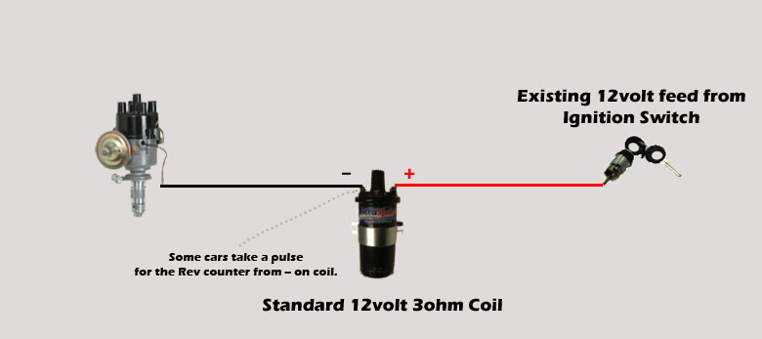

Standard Ignition with AccuSpark Fig 1a
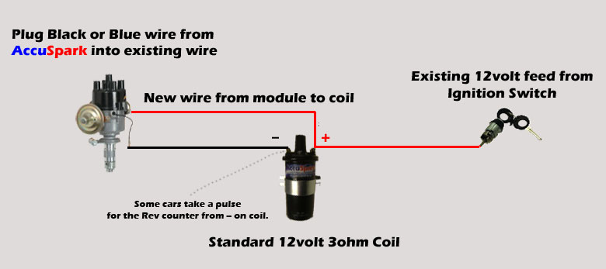

Ballast Ignition
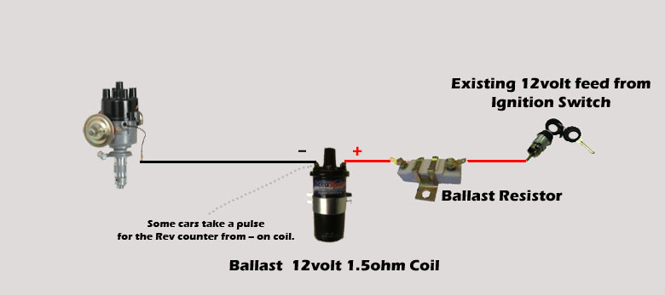

Ballast Ignition with AccuSpark Fig 1b
(For best results connect red AccuSpark wire to 12 volt feed before ballast resistor or ballast wire.)
